Alice Lan

Add a linear plot to the my.boot.smooth function

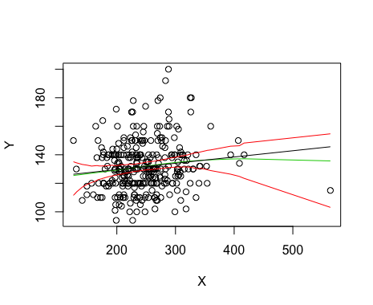

my.boot.smooth function with linear plot line